Wormholes

Space Travel with Wormholes

A wormhole is a hypothetical shortcut between two distant regions of

space-time. Although a three dimensional wormhole is impossible to

fully visualize, a two dimensional analogue can be constructed to

aid visualization. Imagine an intrinsically flat, two dimensional,

space as a folded piece of paper embedded in a higher three

dimensional space, where a tube connects two distant points, A and

B, on the paper. The length through the tube (the wormhole) can be

much less than the distance from A to B along the paper, creating a

shortcut.

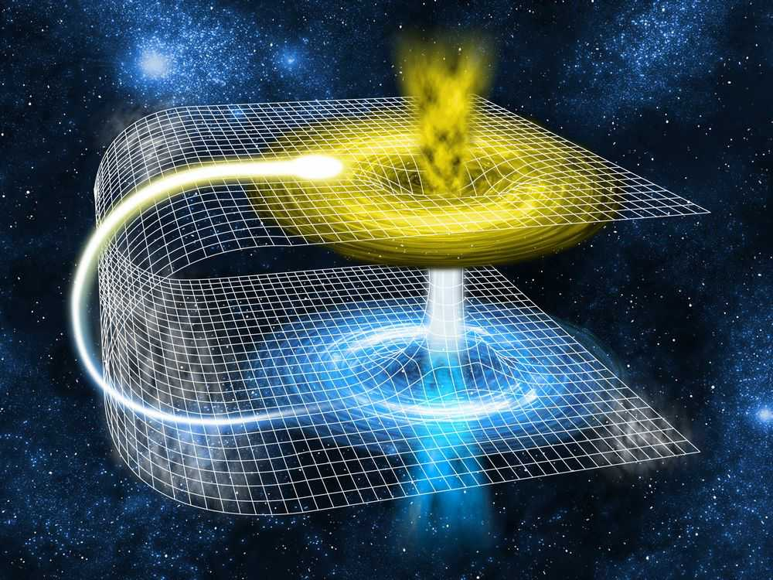

A full three dimensional wormhole would have entrances and exits

that are three dimensional spheres rather than two dimensional rings

like the mouths of the paper tube. Such lower dimensional, human-

friendly, visualizations are termed embedding diagrams, and the

iconic wormhole image is usually shown as the well known

Schwarzchild embedding diagram, which is the wormhole analogue for a

static, non-rotating, Schwarzchild black hole.

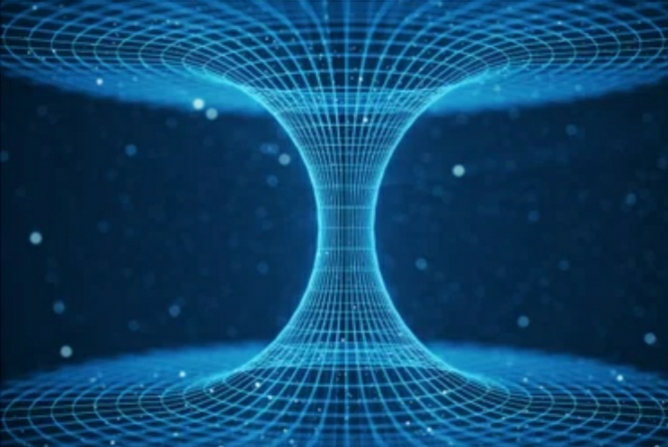

An observer passing through such a wormhole could, in principle,

traverse the wormhole in less time than it would take to travel from

point A to point B through normal space-time outside the wormhole.

Moreover, if A and B are sufficiently distant in space and the

wormhole length is sufficiently short, an observer could potentially

traverse the wormhole in a time less than it would take to send a

light signal from A to B through normal space. Wormholes could thus

be used as a cosmic ``cheat" to effectively bypass the limitation

that no object can travel faster than the speed of light in special

and general relativity. Faster than light travel itself presents

many paradoxes, since it could be used to send messages and

information back in time. Certain other uses of wormholes could

also potentially allow observers themselves to travel into the past.

Time Travel with Wormholes

In addition to facilitating effectively faster than light travel,

wormholes could potentially be used as time machines, in the

following sense first developed by Caltech theoretical physicist Kip

Thorne. Imagine an advanced technology capable of creating,

manipulating, and containing both ends of a stable, traversible,

wormhole. Place one end in a laboratory on Earth and the other on a

spacecraft capable of traveling through space at some reasonable

fraction of the speed of light. Imagine the wormhole connecting the

lab and spaceship is created in some future year, say 2500. Now keep

one end on Earth and send the spaceship off in any direction at some

appreciable fraction of the speed of light for a finite duration

after which it will decelerate, turn around, come back to Earth, and

stop, so the wormholes ends are brought back together.

Relativity tells us that the clocks of observers left on Earth and

those in a relativistically moving spacecraft will begin to differ

by an amount that depends on the speed of the craft. Since moving

clocks run slow in relativity, a spaceship observer might experience

a short subjective duration of say, a few weeks, but thousands or

millions of years could pass in the external universe depending on

how fast they were traveling. In this sense, time travel to the

future is easy, and does not require wormholes, just a ship capable

of moving at relativistic speeds. A spaceship executing the above

maneuver might find itself thousands or millions of years in the

future after stopping. Yet an observer at the wormhole mouth in the

laboratory on Earth would still have its clock synchronized with the

shipboard wormhole. If the ship finds itself, say in year 3500,

after returning to Earth, any observers on the ship could return to

the year 2500, traveling 1000 years into the past, simply by

stepping through their shipboard wormhole back into the laboratory

on Earth.

In this way, wormholes could theoretically be used to travel into

the past. However, in this case, the shipboard time travelers could

never travel to before the year 2500. This poses a striking answer

to the question, ``If time travel to the past is possible, how come

we aren't being constantly visited by time travelers from the

future?" For these types of wormhole time machines, the answer is

simply, because they haven't been invented yet! Time travel of this

sort can never take an observer back to before the original date

when the wormhole connection was set up. This is a particularly

clever resolution to an interesting time travel paradox.

Do Wormholes Actually Exist?

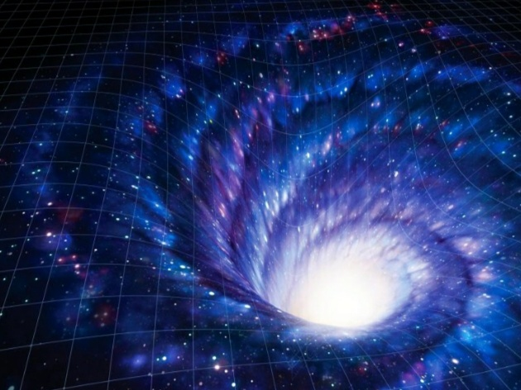

No observational evidence for wormholes currently exists, but

mathematical solutions describing wormholes have long been known to

be valid theoretical solutions to Einstein's field equations of

General Relativity. However, wormholes made completely of normal

matter with positive energy density would be inherently unstable,

and would be likely to collapse in the presence of nearby matter or

matter that tried to traverse the wormhole. However, stable,

traversible wormholes could exist if their entrances and exits were

held open by exotic matter with a negative energy density. Examples

of such exotic matter include the quantum field configuration

responsible for the Casimir Effect in quantum field theory. Whether

such exotic matter could occur naturally in high enough densities to

permit a stable wormhole to form via ordinary physical processes or

whether it could be created artificially with sufficiently advanced

technology remain open theoretical questions.

